# Social Monitoring Mini Project

## Description

The goal of this project is to visualize incoming tweets.

Main use case:

1. User signups and logs into the system
2. User creates words to monitor on twitter in User Interface
3. Agents pulls list of words to monitor from Main apps
4. Agents starts querying Twitter
5. All received tweets are pushed into Main application & stored in database
6. Users starts seeing received tweets in Main application user interface

## Architecture

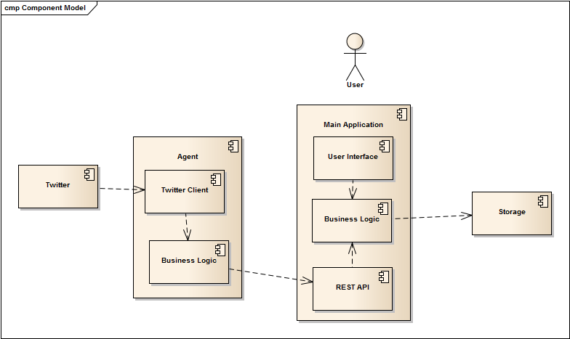

## Modules

### Agent:

* Listens for incoming tweets
* Pushes them into main API via REST/JSON
* Refreshes list every 1 minute.

### Main application

* Provides API to get list of words to listen
* Provides API to store captures tweets
* Signup, login and logout
* Add/edit/remove word to monitor (for logged in users)
* Show in chart list of incoming tweets with auto refresh (for logged in users)

### Implementation details

* UI functionality around word editing and showing tweets should be secured and accessible only to logged in users
* User password should be salted & hashed
* Communication between Agent and Main application happens via REST/JSON interface
* Any twitter client which monitors specific words is fine
* Any chart library, as long as it is JavaScript client side based in fine